CLOUD DEPLOY – Web Application Deployment Platform
1. Introduction
CLOUD DEPLOY is a web application deployment project developed using Amazon Web Services (AWS). The main purpose of this project is to deploy a web application in the cloud, connect it to a database, and make the application accessible to users.
The application is developed using Python Flask. It allows users to enter application names and deployment details through a web interface. The submitted information is stored in a MySQL database hosted on Amazon RDS.
2. AWS Services Used
The main AWS services used in this project are:
- AWS Elastic Beanstalk: Used to deploy and manage the web application.
- Amazon EC2: Provides the virtual server where the application runs.
- Amazon RDS: Stores application records in a MySQL database.
- Amazon S3: Provides storage for files and application packages.
- IAM and VPC: Help manage access permissions and the cloud network.
- CloudWatch: Can be used to monitor application health and logs.

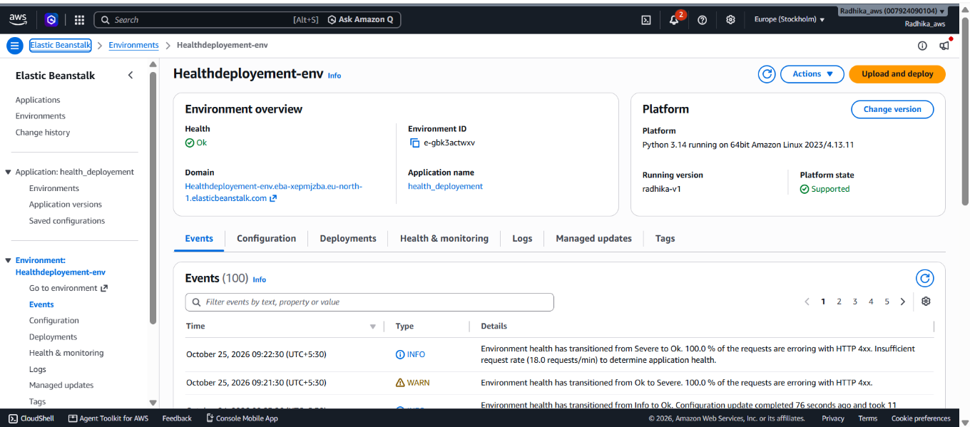

3. Application Development
The application was developed using Python and Flask.
The website contains a form with two input fields:
- Application Name
- Deployment Details
Users can enter information and submit the form. The application saves the information in the database and displays the stored records.
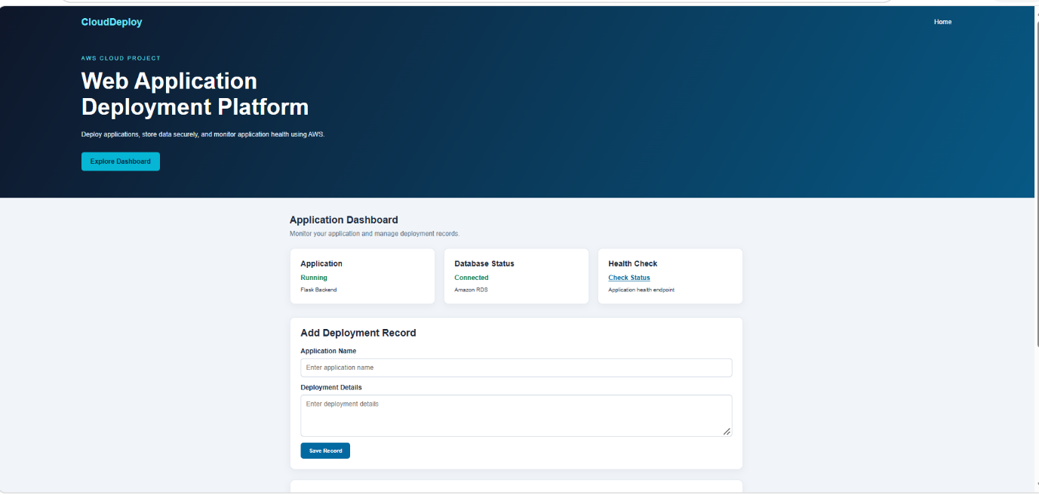
4. Deployment on AWS
The application was deployed using AWS Elastic Beanstalk.
The deployment process involved:
- Preparing the Flask application files.
- Configuring the application to run in the AWS environment.
- Deploying the application using Elastic Beanstalk.
- Accessing the server environment through the terminal when required.
- Configuring the database connection using an environment variable.
- Testing the website through its public IP address.
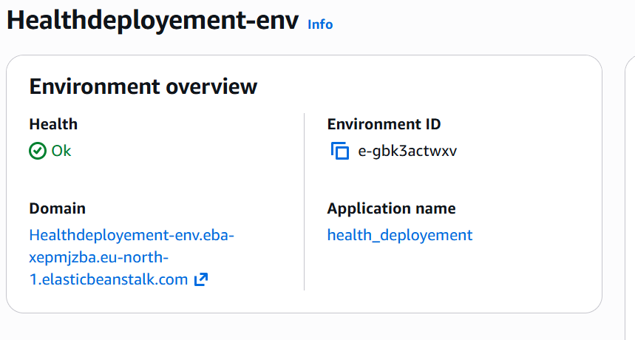
5. Database Integration
Amazon RDS MySQL is used to store the deployment records created through the RADHIKA website.
The database is named employee, and the main table is deployment_note.
THE DATABASE SAVED AS:
ID | Unique record ID
Application name | Name of the application
Deployment details | Details of the deployment
Created at | Date and time the record was created

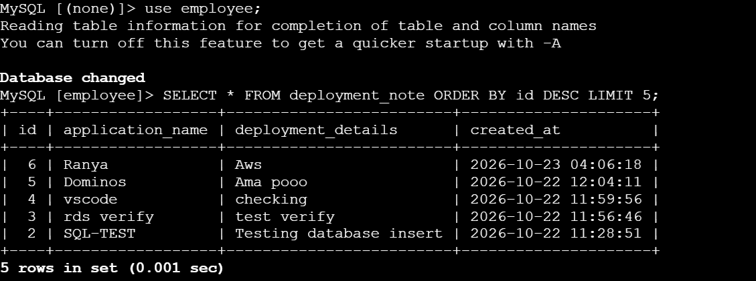

6. Testing and Conclusion
The project demonstrates how to deploy a web application using AWS cloud services.
The Flask application was deployed through AWS Elastic Beanstalk and connected to Amazon RDS MySQL. The application allows users to submit deployment records and view the saved information.
Testing confirmed that records submitted through the website were stored in RDS and displayed successfully.
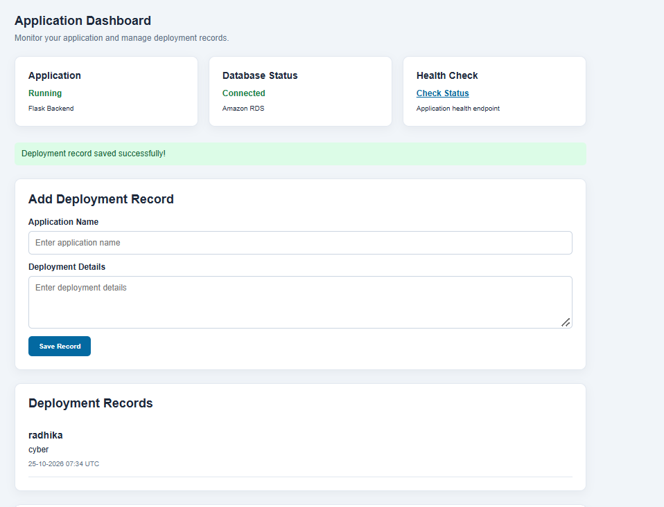
THANK YOU

